Case 4-Eur-Ukraine-Rus-Amulet-Thor’s Lightning-Bronze-700-900 CE

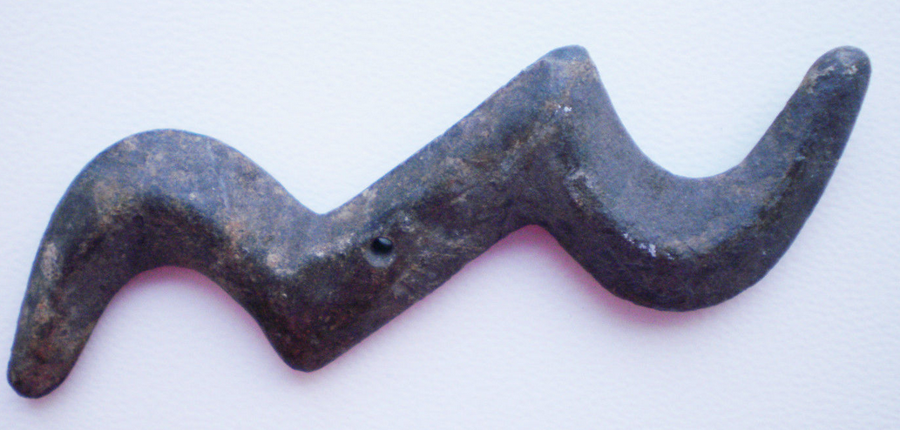

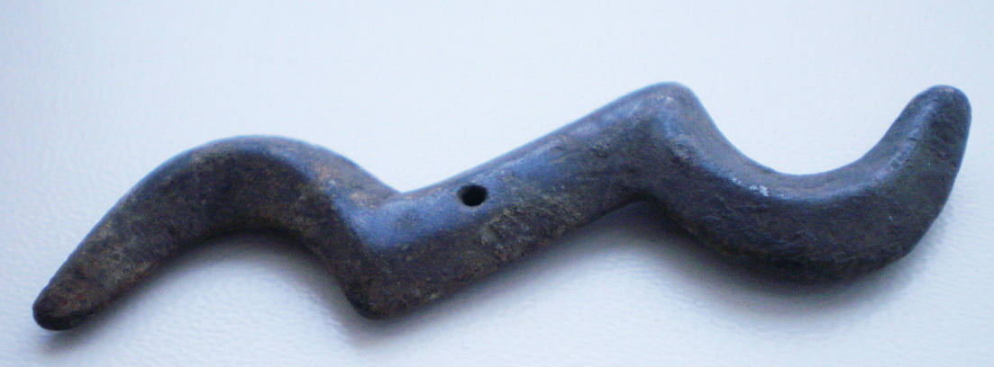

Case 4-Eur-Ukraine-Rus-Amulet-Thor’s Lightning-Bronze-700-900 CE

**Case no.: 4**

**Accession Number:**

**Formal Label:** Eur-Ukraine-Kievan Rus-Sukholuchchya-Pendant-Thor’s Lightning Amulet-Bronze-700-900 CE

**Display Description:**

Beautiful and rare Bronze Viking Thor's lightning bolt amulet. Thor was the god of Thunder and lightning. Seafaring Vikings wore this amulet sometimes to protect themselves against bad weather. It was supposed to make the bad weather go away. 

**LC Classification:** DK70

**Date or Time Horizon:** 700-900 CE

**Geographical Area:** northern Ukraine

**Map:**

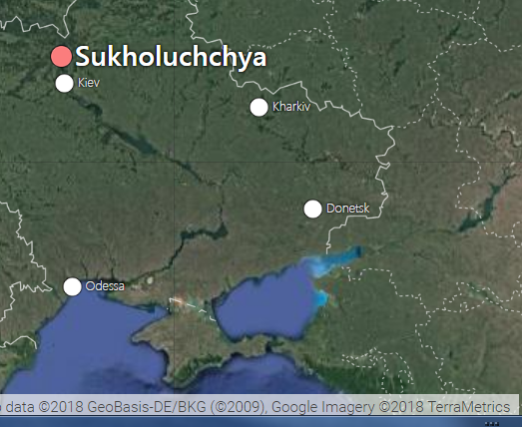

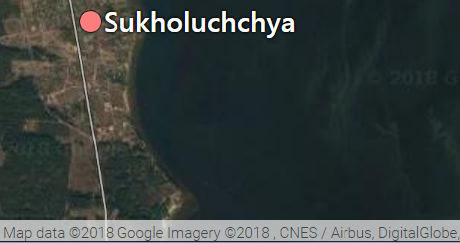

**GPS coordinates:**  51.38424, 32.25778.

**Cultural Affiliation:** Viking Rus

**Medium:** Bronze

**Dimensions:**

**Weight:**

**Condition: original**

**Provenance:** Dutch collection

**Discussion:** The Norman theory of the development of the concept that the name Kievan Rus in the period 700-900 CE had belonged to people from Scandinavia, who in Western Europe were called Normans. Over time, the concept of Rus spread to the territories controlled by the Normans (Kievan Rus), and then the local tribes inhabiting the territory. In the Russian and Soviet historiography, normanism is traditionally opposed to anti-normanism.

Supporters of normanism include the Normans (Vikings of Scandinavian origin) to the founders of the first states of the Eastern Slavs: Novgorod, and then Kievan Rus. In fact, this follows the historiographical concept of the Tale of Bygone Years (the beginning of the 12th century), supplemented by the identification of the chronicled Varangians as Scandinavians-Normans. Around the ethnicity of the Varangians, the main disputes broke out, at times reinforced by political ideologization. Scandinavians themselves noted the abundance of fortified cities in Russia, dubbed it the "country of cities.”

Viking units were often hired by Russian princes as professional combatants, providing them with isolated settlements. This practice continued until the Mongol invasion of Rus'

Vikings made trips down the Dnieper to the Black Sea, the so-called "Way from the Varangians to the Greeks

Today the Rus' remain the final frontier relegated to the European periphery as scholarship continues to expand the idea of medieval Europe beyond "the West.". The Forgotten Kingdom of Rus' challenges the perception of Rus' as an eastern "other"--advancing the idea of the Rus' as a kingdom deeply integrated with medieval Europe. The significance of Thor’s lightning amulet coincides with this growing sense of importance of Rus’ myths and the European sense of power of the ‘elite warrior.

References:

Rybakov, Boris Aleksandrovich. 1989. *Kievskai︠a︠ Ru*s. Mosow : Progress Publishers